EXAMINE VARIABLES=PIa PIb GIa GIb PPDa PPDb CALa CALb BOPa BOPb PISAa PISAb hsCRPa hsCRPb BY IrridatingSolution
/PLOT BOXPLOT HISTOGRAM NPPLOT
/COMPARE GROUP
/STATISTICS DESCRIPTIVES EXTREME
/CINTERVAL 95
/MISSING LISTWISE
/NOTOTAL.

Explore

Notes
Output Created |  | 01-Sep-2021 14:11:26
Comments
Input | Data | C:\Users\Uzoma Ewurum\Desktop\Uzilon\SPSS\DR Ogundana\1-50 combined SPSS.sav
Input | Active Dataset | DataSet1
Input | Filter | <none>
Input | Weight | <none>
Input | Split File | <none>
Input | N of Rows in Working Data File | 50
Missing Value Handling | Definition of Missing | User-defined missing values for dependent variables are treated as missing.
Missing Value Handling | Cases Used | Statistics are based on cases with no missing values for any dependent variable or factor used.
Syntax |  | EXAMINE VARIABLES=PIa PIb GIa GIb PPDa PPDb CALa CALb BOPa BOPb PISAa PISAb hsCRPa hsCRPb BY IrridatingSolution  /PLOT BOXPLOT HISTOGRAM NPPLOT  /COMPARE GROUP  /STATISTICS DESCRIPTIVES EXTREME  /CINTERVAL 95  /MISSING LISTWISE  /NOTOTAL.
Resources | Processor Time | 00:00:08.016
Resources | Elapsed Time | 00:00:08.594

[DataSet1] C:\Users\Uzoma Ewurum\Desktop\Uzilon\SPSS\DR Ogundana\1-50 combined SPSS.sav

Warnings
Text: IrridatingSolution
This procedure cannot use string variables longer than 8 characters. Only the first 8 will be used.

Could not convert ViZML1.4 into ViZML2.0. Error message returned was The XML could not be parsed

An invalid XML character (Unicode: 0x4) was found in the element content of the document..
Could not convert ViZML1.4 into ViZML2.0. Error message returned was The XML could not be parsed

An invalid XML character (Unicode: 0x1) was found in the element content of the document..
Could not convert ViZML1.4 into ViZML2.0. Error message returned was The XML could not be parsed

An invalid XML character (Unicode: 0x1) was found in the element content of the document..
Could not convert ViZML1.4 into ViZML2.0. Error message returned was The XML could not be parsed

An invalid XML character (Unicode: 0x4) was found in the element content of the document..
Could not convert ViZML1.4 into ViZML2.0. Error message returned was The XML could not be parsed

An invalid XML character (Unicode: 0x1) was found in the element content of the document..
Could not convert ViZML1.4 into ViZML2.0. Error message returned was The XML could not be parsed

An invalid XML character (Unicode: 0x1) was found in the element content of the document..
Could not convert ViZML1.4 into ViZML2.0. Error message returned was The XML could not be parsed

An invalid XML character (Unicode: 0x4) was found in the element content of the document..
Could not convert ViZML1.4 into ViZML2.0. Error message returned was The XML could not be parsed

An invalid XML character (Unicode: 0x1) was found in the element content of the document..
Could not convert ViZML1.4 into ViZML2.0. Error message returned was The XML could not be parsed

An invalid XML character (Unicode: 0x1) was found in the element content of the document..
Could not convert ViZML1.4 into ViZML2.0. Error message returned was The XML could not be parsed

An invalid XML character (Unicode: 0x4) was found in the element content of the document..
Could not convert ViZML1.4 into ViZML2.0. Error message returned was The XML could not be parsed

An invalid XML character (Unicode: 0x1) was found in the element content of the document..
Could not convert ViZML1.4 into ViZML2.0. Error message returned was The XML could not be parsed

An invalid XML character (Unicode: 0x1) was found in the element content of the document..
Could not convert ViZML1.4 into ViZML2.0. Error message returned was The XML could not be parsed

An invalid XML character (Unicode: 0x4) was found in the element content of the document..
Could not convert ViZML1.4 into ViZML2.0. Error message returned was The XML could not be parsed

An invalid XML character (Unicode: 0x1) was found in the element content of the document..
Could not convert ViZML1.4 into ViZML2.0. Error message returned was The XML could not be parsed

An invalid XML character (Unicode: 0x1) was found in the element content of the document..
Could not convert ViZML1.4 into ViZML2.0. Error message returned was The XML could not be parsed

An invalid XML character (Unicode: 0x4) was found in the element content of the document..
Could not convert ViZML1.4 into ViZML2.0. Error message returned was The XML could not be parsed

An invalid XML character (Unicode: 0x1) was found in the element content of the document..
Could not convert ViZML1.4 into ViZML2.0. Error message returned was The XML could not be parsed

An invalid XML character (Unicode: 0x1) was found in the element content of the document..
Could not convert ViZML1.4 into ViZML2.0. Error message returned was The XML could not be parsed

An invalid XML character (Unicode: 0x4) was found in the element content of the document..
Could not convert ViZML1.4 into ViZML2.0. Error message returned was The XML could not be parsed

An invalid XML character (Unicode: 0x1) was found in the element content of the document..
Could not convert ViZML1.4 into ViZML2.0. Error message returned was The XML could not be parsed

An invalid XML character (Unicode: 0x1) was found in the element content of the document..
Could not convert ViZML1.4 into ViZML2.0. Error message returned was The XML could not be parsed

An invalid XML character (Unicode: 0x4) was found in the element content of the document..
Could not convert ViZML1.4 into ViZML2.0. Error message returned was The XML could not be parsed

An invalid XML character (Unicode: 0x1) was found in the element content of the document..
Could not convert ViZML1.4 into ViZML2.0. Error message returned was The XML could not be parsed

An invalid XML character (Unicode: 0x1) was found in the element content of the document..
Could not convert ViZML1.4 into ViZML2.0. Error message returned was The XML could not be parsed

An invalid XML character (Unicode: 0x4) was found in the element content of the document..
Could not convert ViZML1.4 into ViZML2.0. Error message returned was The XML could not be parsed

An invalid XML character (Unicode: 0x1) was found in the element content of the document..
Could not convert ViZML1.4 into ViZML2.0. Error message returned was The XML could not be parsed

An invalid XML character (Unicode: 0x1) was found in the element content of the document..
Could not convert ViZML1.4 into ViZML2.0. Error message returned was The XML could not be parsed

An invalid XML character (Unicode: 0x4) was found in the element content of the document..
Could not convert ViZML1.4 into ViZML2.0. Error message returned was The XML could not be parsed

An invalid XML character (Unicode: 0x1) was found in the element content of the document..
Could not convert ViZML1.4 into ViZML2.0. Error message returned was The XML could not be parsed

An invalid XML character (Unicode: 0x1) was found in the element content of the document..
Could not convert ViZML1.4 into ViZML2.0. Error message returned was The XML could not be parsed

An invalid XML character (Unicode: 0x4) was found in the element content of the document..
Could not convert ViZML1.4 into ViZML2.0. Error message returned was The XML could not be parsed

An invalid XML character (Unicode: 0x1) was found in the element content of the document..
Could not convert ViZML1.4 into ViZML2.0. Error message returned was The XML could not be parsed

An invalid XML character (Unicode: 0x1) was found in the element content of the document..
Could not convert ViZML1.4 into ViZML2.0. Error message returned was The XML could not be parsed

An invalid XML character (Unicode: 0x4) was found in the element content of the document..
Could not convert ViZML1.4 into ViZML2.0. Error message returned was The XML could not be parsed

An invalid XML character (Unicode: 0x1) was found in the element content of the document..
Could not convert ViZML1.4 into ViZML2.0. Error message returned was The XML could not be parsed

An invalid XML character (Unicode: 0x1) was found in the element content of the document..
Could not convert ViZML1.4 into ViZML2.0. Error message returned was The XML could not be parsed

An invalid XML character (Unicode: 0x4) was found in the element content of the document..
Could not convert ViZML1.4 into ViZML2.0. Error message returned was The XML could not be parsed

An invalid XML character (Unicode: 0x1) was found in the element content of the document..
Could not convert ViZML1.4 into ViZML2.0. Error message returned was The XML could not be parsed

An invalid XML character (Unicode: 0x1) was found in the element content of the document..
Could not convert ViZML1.4 into ViZML2.0. Error message returned was The XML could not be parsed

An invalid XML character (Unicode: 0x4) was found in the element content of the document..
Could not convert ViZML1.4 into ViZML2.0. Error message returned was The XML could not be parsed

An invalid XML character (Unicode: 0x1) was found in the element content of the document..
Could not convert ViZML1.4 into ViZML2.0. Error message returned was The XML could not be parsed

An invalid XML character (Unicode: 0x1) was found in the element content of the document..

IrridatingSolution

Case Processing Summary
 | IrridatingSolution | Cases
 | IrridatingSolution | Valid |  | Missing |  | Total
 | IrridatingSolution | N | Percent | N | Percent | N | Percent
PIa | chlorhex | 25 | 100.0% | 0 | .0% | 25 | 100.0%
PIa | ozone | 25 | 100.0% | 0 | .0% | 25 | 100.0%
PIb | chlorhex | 25 | 100.0% | 0 | .0% | 25 | 100.0%
PIb | ozone | 25 | 100.0% | 0 | .0% | 25 | 100.0%
GIa | chlorhex | 25 | 100.0% | 0 | .0% | 25 | 100.0%
GIa | ozone | 25 | 100.0% | 0 | .0% | 25 | 100.0%
GIb | chlorhex | 25 | 100.0% | 0 | .0% | 25 | 100.0%
GIb | ozone | 25 | 100.0% | 0 | .0% | 25 | 100.0%
PPDa | chlorhex | 25 | 100.0% | 0 | .0% | 25 | 100.0%
PPDa | ozone | 25 | 100.0% | 0 | .0% | 25 | 100.0%
PPDb | chlorhex | 25 | 100.0% | 0 | .0% | 25 | 100.0%
PPDb | ozone | 25 | 100.0% | 0 | .0% | 25 | 100.0%
CALa | chlorhex | 25 | 100.0% | 0 | .0% | 25 | 100.0%
CALa | ozone | 25 | 100.0% | 0 | .0% | 25 | 100.0%
CALb | chlorhex | 25 | 100.0% | 0 | .0% | 25 | 100.0%
CALb | ozone | 25 | 100.0% | 0 | .0% | 25 | 100.0%
BOPa | chlorhex | 25 | 100.0% | 0 | .0% | 25 | 100.0%
BOPa | ozone | 25 | 100.0% | 0 | .0% | 25 | 100.0%
BOPb | chlorhex | 25 | 100.0% | 0 | .0% | 25 | 100.0%
BOPb | ozone | 25 | 100.0% | 0 | .0% | 25 | 100.0%
PISAa | chlorhex | 25 | 100.0% | 0 | .0% | 25 | 100.0%
PISAa | ozone | 25 | 100.0% | 0 | .0% | 25 | 100.0%
PISAb | chlorhex | 25 | 100.0% | 0 | .0% | 25 | 100.0%
PISAb | ozone | 25 | 100.0% | 0 | .0% | 25 | 100.0%
hsCRPa | chlorhex | 25 | 100.0% | 0 | .0% | 25 | 100.0%
hsCRPa | ozone | 25 | 100.0% | 0 | .0% | 25 | 100.0%
hsCRPb | chlorhex | 25 | 100.0% | 0 | .0% | 25 | 100.0%
hsCRPb | ozone | 25 | 100.0% | 0 | .0% | 25 | 100.0%

Descriptives
 | IrridatingSolution |  |  | Statistic | Std. Error
PIa | chlorhex | Mean |  | 2.076 | .0886
PIa | chlorhex | 95% Confidence Interval for Mean | Lower Bound | 1.893
PIa | chlorhex | 95% Confidence Interval for Mean | Upper Bound | 2.259
PIa | chlorhex | 5% Trimmed Mean |  | 2.077
PIa | chlorhex | Median |  | 2.200
PIa | chlorhex | Variance |  | .196
PIa | chlorhex | Std. Deviation |  | .4428
PIa | chlorhex | Minimum |  | 1.3
PIa | chlorhex | Maximum |  | 2.8
PIa | chlorhex | Range |  | 1.5
PIa | chlorhex | Interquartile Range |  | .8
PIa | chlorhex | Skewness |  | .020 | .464
PIa | chlorhex | Kurtosis |  | -1.143 | .902
PIa | ozone | Mean |  | 2.160 | .0876
PIa | ozone | 95% Confidence Interval for Mean | Lower Bound | 1.979
PIa | ozone | 95% Confidence Interval for Mean | Upper Bound | 2.341
PIa | ozone | 5% Trimmed Mean |  | 2.177
PIa | ozone | Median |  | 2.200
PIa | ozone | Variance |  | .192
PIa | ozone | Std. Deviation |  | .4378
PIa | ozone | Minimum |  | 1.2
PIa | ozone | Maximum |  | 2.8
PIa | ozone | Range |  | 1.6
PIa | ozone | Interquartile Range |  | .7
PIa | ozone | Skewness |  | -.506 | .464
PIa | ozone | Kurtosis |  | -.279 | .902
PIb | chlorhex | Mean |  | 1.448 | .0356
PIb | chlorhex | 95% Confidence Interval for Mean | Lower Bound | 1.374
PIb | chlorhex | 95% Confidence Interval for Mean | Upper Bound | 1.522
PIb | chlorhex | 5% Trimmed Mean |  | 1.441
PIb | chlorhex | Median |  | 1.500
PIb | chlorhex | Variance |  | .032
PIb | chlorhex | Std. Deviation |  | .1782
PIb | chlorhex | Minimum |  | 1.2
PIb | chlorhex | Maximum |  | 1.8
PIb | chlorhex | Range |  | .6
PIb | chlorhex | Interquartile Range |  | .2
PIb | chlorhex | Skewness |  | .684 | .464
PIb | chlorhex | Kurtosis |  | -.661 | .902
PIb | ozone | Mean |  | 1.156 | .0529
PIb | ozone | 95% Confidence Interval for Mean | Lower Bound | 1.047
PIb | ozone | 95% Confidence Interval for Mean | Upper Bound | 1.265
PIb | ozone | 5% Trimmed Mean |  | 1.153
PIb | ozone | Median |  | 1.200
PIb | ozone | Variance |  | .070
PIb | ozone | Std. Deviation |  | .2647
PIb | ozone | Minimum |  | .7
PIb | ozone | Maximum |  | 1.7
PIb | ozone | Range |  | 1.0
PIb | ozone | Interquartile Range |  | .4
PIb | ozone | Skewness |  | -.271 | .464
PIb | ozone | Kurtosis |  | -.461 | .902
GIa | chlorhex | Mean |  | 1.764 | .0624
GIa | chlorhex | 95% Confidence Interval for Mean | Lower Bound | 1.635
GIa | chlorhex | 95% Confidence Interval for Mean | Upper Bound | 1.893
GIa | chlorhex | 5% Trimmed Mean |  | 1.760
GIa | chlorhex | Median |  | 1.700
GIa | chlorhex | Variance |  | .097
GIa | chlorhex | Std. Deviation |  | .3121
GIa | chlorhex | Minimum |  | 1.3
GIa | chlorhex | Maximum |  | 2.3
GIa | chlorhex | Range |  | 1.0
GIa | chlorhex | Interquartile Range |  | .5
GIa | chlorhex | Skewness |  | .213 | .464
GIa | chlorhex | Kurtosis |  | -.946 | .902
GIa | ozone | Mean |  | 2.112 | .0884
GIa | ozone | 95% Confidence Interval for Mean | Lower Bound | 1.930
GIa | ozone | 95% Confidence Interval for Mean | Upper Bound | 2.294
GIa | ozone | 5% Trimmed Mean |  | 2.117
GIa | ozone | Median |  | 2.200
GIa | ozone | Variance |  | .195
GIa | ozone | Std. Deviation |  | .4419
GIa | ozone | Minimum |  | 1.3
GIa | ozone | Maximum |  | 2.8
GIa | ozone | Range |  | 1.5
GIa | ozone | Interquartile Range |  | .8
GIa | ozone | Skewness |  | -.109 | .464
GIa | ozone | Kurtosis |  | -1.011 | .902
GIb | chlorhex | Mean |  | 1.456 | .0392
GIb | chlorhex | 95% Confidence Interval for Mean | Lower Bound | 1.375
GIb | chlorhex | 95% Confidence Interval for Mean | Upper Bound | 1.537
GIb | chlorhex | 5% Trimmed Mean |  | 1.452
GIb | chlorhex | Median |  | 1.500
GIb | chlorhex | Variance |  | .038
GIb | chlorhex | Std. Deviation |  | .1960
GIb | chlorhex | Minimum |  | 1.2
GIb | chlorhex | Maximum |  | 1.8
GIb | chlorhex | Range |  | .6
GIb | chlorhex | Interquartile Range |  | .4
GIb | chlorhex | Skewness |  | .209 | .464
GIb | chlorhex | Kurtosis |  | -1.360 | .902
GIb | ozone | Mean |  | 1.200 | .0424
GIb | ozone | 95% Confidence Interval for Mean | Lower Bound | 1.112
GIb | ozone | 95% Confidence Interval for Mean | Upper Bound | 1.288
GIb | ozone | 5% Trimmed Mean |  | 1.206
GIb | ozone | Median |  | 1.200
GIb | ozone | Variance |  | .045
GIb | ozone | Std. Deviation |  | .2121
GIb | ozone | Minimum |  | .8
GIb | ozone | Maximum |  | 1.5
GIb | ozone | Range |  | .7
GIb | ozone | Interquartile Range |  | .3
GIb | ozone | Skewness |  | -.512 | .464
GIb | ozone | Kurtosis |  | -.338 | .902
PPDa | chlorhex | Mean |  | 7.40 | .277
PPDa | chlorhex | 95% Confidence Interval for Mean | Lower Bound | 6.83
PPDa | chlorhex | 95% Confidence Interval for Mean | Upper Bound | 7.97
PPDa | chlorhex | 5% Trimmed Mean |  | 7.33
PPDa | chlorhex | Median |  | 7.00
PPDa | chlorhex | Variance |  | 1.917
PPDa | chlorhex | Std. Deviation |  | 1.384
PPDa | chlorhex | Minimum |  | 5
PPDa | chlorhex | Maximum |  | 11
PPDa | chlorhex | Range |  | 6
PPDa | chlorhex | Interquartile Range |  | 2
PPDa | chlorhex | Skewness |  | .737 | .464
PPDa | chlorhex | Kurtosis |  | .724 | .902
PPDa | ozone | Mean |  | 6.96 | .234
PPDa | ozone | 95% Confidence Interval for Mean | Lower Bound | 6.48
PPDa | ozone | 95% Confidence Interval for Mean | Upper Bound | 7.44
PPDa | ozone | 5% Trimmed Mean |  | 6.92
PPDa | ozone | Median |  | 7.00
PPDa | ozone | Variance |  | 1.373
PPDa | ozone | Std. Deviation |  | 1.172
PPDa | ozone | Minimum |  | 5
PPDa | ozone | Maximum |  | 10
PPDa | ozone | Range |  | 5
PPDa | ozone | Interquartile Range |  | 2
PPDa | ozone | Skewness |  | .421 | .464
PPDa | ozone | Kurtosis |  | .305 | .902
PPDb | chlorhex | Mean |  | 3.76 | .156
PPDb | chlorhex | 95% Confidence Interval for Mean | Lower Bound | 3.44
PPDb | chlorhex | 95% Confidence Interval for Mean | Upper Bound | 4.08
PPDb | chlorhex | 5% Trimmed Mean |  | 3.69
PPDb | chlorhex | Median |  | 4.00
PPDb | chlorhex | Variance |  | .607
PPDb | chlorhex | Std. Deviation |  | .779
PPDb | chlorhex | Minimum |  | 3
PPDb | chlorhex | Maximum |  | 6
PPDb | chlorhex | Range |  | 3
PPDb | chlorhex | Interquartile Range |  | 1
PPDb | chlorhex | Skewness |  | 1.038 | .464
PPDb | chlorhex | Kurtosis |  | 1.425 | .902
PPDb | ozone | Mean |  | 3.40 | .141
PPDb | ozone | 95% Confidence Interval for Mean | Lower Bound | 3.11
PPDb | ozone | 95% Confidence Interval for Mean | Upper Bound | 3.69
PPDb | ozone | 5% Trimmed Mean |  | 3.38
PPDb | ozone | Median |  | 3.00
PPDb | ozone | Variance |  | .500
PPDb | ozone | Std. Deviation |  | .707
PPDb | ozone | Minimum |  | 2
PPDb | ozone | Maximum |  | 5
PPDb | ozone | Range |  | 3
PPDb | ozone | Interquartile Range |  | 1
PPDb | ozone | Skewness |  | .769 | .464
PPDb | ozone | Kurtosis |  | .490 | .902
CALa | chlorhex | Mean |  | 4.36 | .282
CALa | chlorhex | 95% Confidence Interval for Mean | Lower Bound | 3.78
CALa | chlorhex | 95% Confidence Interval for Mean | Upper Bound | 4.94
CALa | chlorhex | 5% Trimmed Mean |  | 4.29
CALa | chlorhex | Median |  | 4.00
CALa | chlorhex | Variance |  | 1.990
CALa | chlorhex | Std. Deviation |  | 1.411
CALa | chlorhex | Minimum |  | 2
CALa | chlorhex | Maximum |  | 8
CALa | chlorhex | Range |  | 6
CALa | chlorhex | Interquartile Range |  | 2
CALa | chlorhex | Skewness |  | .746 | .464
CALa | chlorhex | Kurtosis |  | .570 | .902
CALa | ozone | Mean |  | 3.96 | .234
CALa | ozone | 95% Confidence Interval for Mean | Lower Bound | 3.48
CALa | ozone | 95% Confidence Interval for Mean | Upper Bound | 4.44
CALa | ozone | 5% Trimmed Mean |  | 3.92
CALa | ozone | Median |  | 4.00
CALa | ozone | Variance |  | 1.373
CALa | ozone | Std. Deviation |  | 1.172
CALa | ozone | Minimum |  | 2
CALa | ozone | Maximum |  | 7
CALa | ozone | Range |  | 5
CALa | ozone | Interquartile Range |  | 2
CALa | ozone | Skewness |  | .421 | .464
CALa | ozone | Kurtosis |  | .305 | .902
CALb | chlorhex | Mean |  | .76 | .156
CALb | chlorhex | 95% Confidence Interval for Mean | Lower Bound | .44
CALb | chlorhex | 95% Confidence Interval for Mean | Upper Bound | 1.08
CALb | chlorhex | 5% Trimmed Mean |  | .69
CALb | chlorhex | Median |  | 1.00
CALb | chlorhex | Variance |  | .607
CALb | chlorhex | Std. Deviation |  | .779
CALb | chlorhex | Minimum |  | 0
CALb | chlorhex | Maximum |  | 3
CALb | chlorhex | Range |  | 3
CALb | chlorhex | Interquartile Range |  | 1
CALb | chlorhex | Skewness |  | 1.038 | .464
CALb | chlorhex | Kurtosis |  | 1.425 | .902
CALb | ozone | Mean |  | .44 | .130
CALb | ozone | 95% Confidence Interval for Mean | Lower Bound | .17
CALb | ozone | 95% Confidence Interval for Mean | Upper Bound | .71
CALb | ozone | 5% Trimmed Mean |  | .38
CALb | ozone | Median |  | .00
CALb | ozone | Variance |  | .423
CALb | ozone | Std. Deviation |  | .651
CALb | ozone | Minimum |  | 0
CALb | ozone | Maximum |  | 2
CALb | ozone | Range |  | 2
CALb | ozone | Interquartile Range |  | 1
CALb | ozone | Skewness |  | 1.227 | .464
CALb | ozone | Kurtosis |  | .507 | .902
BOPa | chlorhex | Mean |  | 58.737 | 2.4861
BOPa | chlorhex | 95% Confidence Interval for Mean | Lower Bound | 53.606
BOPa | chlorhex | 95% Confidence Interval for Mean | Upper Bound | 63.868
BOPa | chlorhex | 5% Trimmed Mean |  | 58.591
BOPa | chlorhex | Median |  | 56.550
BOPa | chlorhex | Variance |  | 154.514
BOPa | chlorhex | Std. Deviation |  | 12.4304
BOPa | chlorhex | Minimum |  | 38.7
BOPa | chlorhex | Maximum |  | 81.5
BOPa | chlorhex | Range |  | 42.9
BOPa | chlorhex | Interquartile Range |  | 19.0
BOPa | chlorhex | Skewness |  | .226 | .464
BOPa | chlorhex | Kurtosis |  | -.889 | .902
BOPa | ozone | Mean |  | 48.601 | 2.8414
BOPa | ozone | 95% Confidence Interval for Mean | Lower Bound | 42.737
BOPa | ozone | 95% Confidence Interval for Mean | Upper Bound | 54.465
BOPa | ozone | 5% Trimmed Mean |  | 48.512
BOPa | ozone | Median |  | 45.430
BOPa | ozone | Variance |  | 201.832
BOPa | ozone | Std. Deviation |  | 14.2068
BOPa | ozone | Minimum |  | 22.0
BOPa | ozone | Maximum |  | 75.6
BOPa | ozone | Range |  | 53.6
BOPa | ozone | Interquartile Range |  | 20.2
BOPa | ozone | Skewness |  | .259 | .464
BOPa | ozone | Kurtosis |  | -.431 | .902
BOPb | chlorhex | Mean |  | 21.4280 | 2.67224
BOPb | chlorhex | 95% Confidence Interval for Mean | Lower Bound | 15.9128
BOPb | chlorhex | 95% Confidence Interval for Mean | Upper Bound | 26.9432
BOPb | chlorhex | 5% Trimmed Mean |  | 20.8857
BOPb | chlorhex | Median |  | 17.2600
BOPb | chlorhex | Variance |  | 178.521
BOPb | chlorhex | Std. Deviation |  | 1.33612E1
BOPb | chlorhex | Minimum |  | 4.76
BOPb | chlorhex | Maximum |  | 47.62
BOPb | chlorhex | Range |  | 42.86
BOPb | chlorhex | Interquartile Range |  | 18.75
BOPb | chlorhex | Skewness |  | .807 | .464
BOPb | chlorhex | Kurtosis |  | -.341 | .902
BOPb | ozone | Mean |  | 8.0244 | .55284
BOPb | ozone | 95% Confidence Interval for Mean | Lower Bound | 6.8834
BOPb | ozone | 95% Confidence Interval for Mean | Upper Bound | 9.1654
BOPb | ozone | 5% Trimmed Mean |  | 8.0428
BOPb | ozone | Median |  | 8.3300
BOPb | ozone | Variance |  | 7.641
BOPb | ozone | Std. Deviation |  | 2.76421
BOPb | ozone | Minimum |  | 2.98
BOPb | ozone | Maximum |  | 12.50
BOPb | ozone | Range |  | 9.52
BOPb | ozone | Interquartile Range |  | 4.76
BOPb | ozone | Skewness |  | .067 | .464
BOPb | ozone | Kurtosis |  | -1.006 | .902
PISAa | chlorhex | Mean |  | 1.112E3 | 52.9130
PISAa | chlorhex | 95% Confidence Interval for Mean | Lower Bound | 1.002E3
PISAa | chlorhex | 95% Confidence Interval for Mean | Upper Bound | 1.221E3
PISAa | chlorhex | 5% Trimmed Mean |  | 1.101E3
PISAa | chlorhex | Median |  | 1.109E3
PISAa | chlorhex | Variance |  | 6.999E4
PISAa | chlorhex | Std. Deviation |  | 2.6457E2
PISAa | chlorhex | Minimum |  | 741.9
PISAa | chlorhex | Maximum |  | 1703.8
PISAa | chlorhex | Range |  | 961.9
PISAa | chlorhex | Interquartile Range |  | 307.8
PISAa | chlorhex | Skewness |  | .487 | .464
PISAa | chlorhex | Kurtosis |  | -.125 | .902
PISAa | ozone | Mean |  | 1.005E3 | 74.8418
PISAa | ozone | 95% Confidence Interval for Mean | Lower Bound | 850.270
PISAa | ozone | 95% Confidence Interval for Mean | Upper Bound | 1.159E3
PISAa | ozone | 5% Trimmed Mean |  | 987.957
PISAa | ozone | Median |  | 1.008E3
PISAa | ozone | Variance |  | 1.400E5
PISAa | ozone | Std. Deviation |  | 3.7421E2
PISAa | ozone | Minimum |  | 370.6
PISAa | ozone | Maximum |  | 1991.7
PISAa | ozone | Range |  | 1621.1
PISAa | ozone | Interquartile Range |  | 572.6
PISAa | ozone | Skewness |  | .566 | .464
PISAa | ozone | Kurtosis |  | .721 | .902
PISAb | chlorhex | Mean |  | 222.256 | 34.8436
PISAb | chlorhex | 95% Confidence Interval for Mean | Lower Bound | 150.342
PISAb | chlorhex | 95% Confidence Interval for Mean | Upper Bound | 294.170
PISAb | chlorhex | 5% Trimmed Mean |  | 213.628
PISAb | chlorhex | Median |  | 127.900
PISAb | chlorhex | Variance |  | 3.035E4
PISAb | chlorhex | Std. Deviation |  | 1.7422E2
PISAb | chlorhex | Minimum |  | 34.1
PISAb | chlorhex | Maximum |  | 562.5
PISAb | chlorhex | Range |  | 528.4
PISAb | chlorhex | Interquartile Range |  | 292.6
PISAb | chlorhex | Skewness |  | .766 | .464
PISAb | chlorhex | Kurtosis |  | -.816 | .902
PISAb | ozone | Mean |  | 122.768 | 10.4811
PISAb | ozone | 95% Confidence Interval for Mean | Lower Bound | 101.136
PISAb | ozone | 95% Confidence Interval for Mean | Upper Bound | 144.400
PISAb | ozone | 5% Trimmed Mean |  | 121.649
PISAb | ozone | Median |  | 111.400
PISAb | ozone | Variance |  | 2.746E3
PISAb | ozone | Std. Deviation |  | 52.4057
PISAb | ozone | Minimum |  | 21.4
PISAb | ozone | Maximum |  | 245.3
PISAb | ozone | Range |  | 223.9
PISAb | ozone | Interquartile Range |  | 70.0
PISAb | ozone | Skewness |  | .492 | .464
PISAb | ozone | Kurtosis |  | .125 | .902
hsCRPa | chlorhex | Mean |  | 2.536 | .5473
hsCRPa | chlorhex | 95% Confidence Interval for Mean | Lower Bound | 1.407
hsCRPa | chlorhex | 95% Confidence Interval for Mean | Upper Bound | 3.665
hsCRPa | chlorhex | 5% Trimmed Mean |  | 2.256
hsCRPa | chlorhex | Median |  | 1.400
hsCRPa | chlorhex | Variance |  | 7.487
hsCRPa | chlorhex | Std. Deviation |  | 2.7363
hsCRPa | chlorhex | Minimum |  | .3
hsCRPa | chlorhex | Maximum |  | 9.8
hsCRPa | chlorhex | Range |  | 9.5
hsCRPa | chlorhex | Interquartile Range |  | 3.7
hsCRPa | chlorhex | Skewness |  | 1.619 | .464
hsCRPa | chlorhex | Kurtosis |  | 2.224 | .902
hsCRPa | ozone | Mean |  | 1.856 | .3367
hsCRPa | ozone | 95% Confidence Interval for Mean | Lower Bound | 1.161
hsCRPa | ozone | 95% Confidence Interval for Mean | Upper Bound | 2.551
hsCRPa | ozone | 5% Trimmed Mean |  | 1.757
hsCRPa | ozone | Median |  | .900
hsCRPa | ozone | Variance |  | 2.834
hsCRPa | ozone | Std. Deviation |  | 1.6835
hsCRPa | ozone | Minimum |  | .5
hsCRPa | ozone | Maximum |  | 5.0
hsCRPa | ozone | Range |  | 4.5
hsCRPa | ozone | Interquartile Range |  | 2.4
hsCRPa | ozone | Skewness |  | .989 | .464
hsCRPa | ozone | Kurtosis |  | -.475 | .902
hsCRPb | chlorhex | Mean |  | 1.488 | .3797
hsCRPb | chlorhex | 95% Confidence Interval for Mean | Lower Bound | .704
hsCRPb | chlorhex | 95% Confidence Interval for Mean | Upper Bound | 2.272
hsCRPb | chlorhex | 5% Trimmed Mean |  | 1.292
hsCRPb | chlorhex | Median |  | .500
hsCRPb | chlorhex | Variance |  | 3.604
hsCRPb | chlorhex | Std. Deviation |  | 1.8983
hsCRPb | chlorhex | Minimum |  | .1
hsCRPb | chlorhex | Maximum |  | 6.4
hsCRPb | chlorhex | Range |  | 6.3
hsCRPb | chlorhex | Interquartile Range |  | 1.7
hsCRPb | chlorhex | Skewness |  | 1.678 | .464
hsCRPb | chlorhex | Kurtosis |  | 1.905 | .902
hsCRPb | ozone | Mean |  | 1.164 | .2246
hsCRPb | ozone | 95% Confidence Interval for Mean | Lower Bound | .700
hsCRPb | ozone | 95% Confidence Interval for Mean | Upper Bound | 1.628
hsCRPb | ozone | 5% Trimmed Mean |  | 1.050
hsCRPb | ozone | Median |  | .600
hsCRPb | ozone | Variance |  | 1.262
hsCRPb | ozone | Std. Deviation |  | 1.1232
hsCRPb | ozone | Minimum |  | .3
hsCRPb | ozone | Maximum |  | 4.3
hsCRPb | ozone | Range |  | 4.0
hsCRPb | ozone | Interquartile Range |  | 1.2
hsCRPb | ozone | Skewness |  | 1.546 | .464
hsCRPb | ozone | Kurtosis |  | 1.302 | .902

Extreme Values
 | IrridatingSolution |  |  | Case Number | Value
PIa | chlorhex | Highest | 1 | 34 | 2.8
PIa | chlorhex | Highest | 2 | 42 | 2.8
PIa | chlorhex | Highest | 3 | 44 | 2.7
PIa | chlorhex | Highest | 4 | 26 | 2.5
PIa | chlorhex | Highest | 5 | 29 | 2.5ª
PIa | chlorhex | Lowest | 1 | 36 | 1.3
PIa | chlorhex | Lowest | 2 | 46 | 1.5
PIa | chlorhex | Lowest | 3 | 35 | 1.5
PIa | chlorhex | Lowest | 4 | 28 | 1.5
PIa | chlorhex | Lowest | 5 | 49 | 1.6
PIa | ozone | Highest | 1 | 8 | 2.8
PIa | ozone | Highest | 2 | 21 | 2.8
PIa | ozone | Highest | 3 | 2 | 2.7
PIa | ozone | Highest | 4 | 20 | 2.7
PIa | ozone | Highest | 5 | 6 | 2.5ª
PIa | ozone | Lowest | 1 | 4 | 1.2
PIa | ozone | Lowest | 2 | 3 | 1.3
PIa | ozone | Lowest | 3 | 24 | 1.6
PIa | ozone | Lowest | 4 | 10 | 1.7
PIa | ozone | Lowest | 5 | 23 | 1.8^{b}
PIb | chlorhex | Highest | 1 | 34 | 1.8
PIb | chlorhex | Highest | 2 | 38 | 1.8
PIb | chlorhex | Highest | 3 | 31 | 1.7
PIb | chlorhex | Highest | 4 | 32 | 1.7
PIb | chlorhex | Highest | 5 | 47 | 1.7
PIb | chlorhex | Lowest | 1 | 36 | 1.2
PIb | chlorhex | Lowest | 2 | 49 | 1.3
PIb | chlorhex | Lowest | 3 | 48 | 1.3
PIb | chlorhex | Lowest | 4 | 46 | 1.3
PIb | chlorhex | Lowest | 5 | 44 | 1.3^{c}
PIb | ozone | Highest | 1 | 20 | 1.7
PIb | ozone | Highest | 2 | 2 | 1.5
PIb | ozone | Highest | 3 | 21 | 1.5
PIb | ozone | Highest | 4 | 1 | 1.3
PIb | ozone | Highest | 5 | 6 | 1.3^{d}
PIb | ozone | Lowest | 1 | 11 | .7
PIb | ozone | Lowest | 2 | 4 | .7
PIb | ozone | Lowest | 3 | 25 | .8
PIb | ozone | Lowest | 4 | 17 | .8
PIb | ozone | Lowest | 5 | 15 | .8e
GIa | chlorhex | Highest | 1 | 26 | 2.3
GIa | chlorhex | Highest | 2 | 29 | 2.3
GIa | chlorhex | Highest | 3 | 32 | 2.3
GIa | chlorhex | Highest | 4 | 27 | 2.0
GIa | chlorhex | Highest | 5 | 30 | 2.0^{f}
GIa | chlorhex | Lowest | 1 | 49 | 1.3
GIa | chlorhex | Lowest | 2 | 46 | 1.3
GIa | chlorhex | Lowest | 3 | 38 | 1.3
GIa | chlorhex | Lowest | 4 | 48 | 1.5
GIa | chlorhex | Lowest | 5 | 45 | 1.5^{g}
GIa | ozone | Highest | 1 | 1 | 2.8
GIa | ozone | Highest | 2 | 2 | 2.8
GIa | ozone | Highest | 3 | 21 | 2.7
GIa | ozone | Highest | 4 | 25 | 2.7
GIa | ozone | Highest | 5 | 12 | 2.5ª
GIa | ozone | Lowest | 1 | 19 | 1.3
GIa | ozone | Lowest | 2 | 13 | 1.5
GIa | ozone | Lowest | 3 | 5 | 1.5
GIa | ozone | Lowest | 4 | 4 | 1.5
GIa | ozone | Lowest | 5 | 23 | 1.7^{h}
GIb | chlorhex | Highest | 1 | 32 | 1.8
GIb | chlorhex | Highest | 2 | 26 | 1.7
GIb | chlorhex | Highest | 3 | 29 | 1.7
GIb | chlorhex | Highest | 4 | 31 | 1.7
GIb | chlorhex | Highest | 5 | 37 | 1.7^{i}
GIb | chlorhex | Lowest | 1 | 49 | 1.2
GIb | chlorhex | Lowest | 2 | 48 | 1.2
GIb | chlorhex | Lowest | 3 | 46 | 1.2
GIb | chlorhex | Lowest | 4 | 38 | 1.2
GIb | chlorhex | Lowest | 5 | 47 | 1.3^{c}
GIb | ozone | Highest | 1 | 2 | 1.5
GIb | ozone | Highest | 2 | 15 | 1.5
GIb | ozone | Highest | 3 | 17 | 1.5
GIb | ozone | Highest | 4 | 18 | 1.5
GIb | ozone | Highest | 5 | 1 | 1.3^{d}
GIb | ozone | Lowest | 1 | 13 | .8
GIb | ozone | Lowest | 2 | 9 | .8
GIb | ozone | Lowest | 3 | 5 | .8
GIb | ozone | Lowest | 4 | 24 | 1.0
GIb | ozone | Lowest | 5 | 20 | 1.0^{j}
PPDa | chlorhex | Highest | 1 | 42 | 11
PPDa | chlorhex | Highest | 2 | 44 | 10
PPDa | chlorhex | Highest | 3 | 26 | 9
PPDa | chlorhex | Highest | 4 | 29 | 9
PPDa | chlorhex | Highest | 5 | 31 | 8^{k}
PPDa | chlorhex | Lowest | 1 | 36 | 5
PPDa | chlorhex | Lowest | 2 | 49 | 6
PPDa | chlorhex | Lowest | 3 | 47 | 6
PPDa | chlorhex | Lowest | 4 | 40 | 6
PPDa | chlorhex | Lowest | 5 | 35 | 6^{l}
PPDa | ozone | Highest | 1 | 13 | 10
PPDa | ozone | Highest | 2 | 1 | 8
PPDa | ozone | Highest | 3 | 6 | 8
PPDa | ozone | Highest | 4 | 7 | 8
PPDa | ozone | Highest | 5 | 8 | 8^{k}
PPDa | ozone | Lowest | 1 | 18 | 5
PPDa | ozone | Lowest | 2 | 14 | 5
PPDa | ozone | Lowest | 3 | 23 | 6
PPDa | ozone | Lowest | 4 | 17 | 6
PPDa | ozone | Lowest | 5 | 15 | 6^{l}
PPDb | chlorhex | Highest | 1 | 42 | 6
PPDb | chlorhex | Highest | 2 | 31 | 5
PPDb | chlorhex | Highest | 3 | 44 | 5
PPDb | chlorhex | Highest | 4 | 26 | 4
PPDb | chlorhex | Highest | 5 | 28 | 4^{m}
PPDb | chlorhex | Lowest | 1 | 49 | 3
PPDb | chlorhex | Lowest | 2 | 46 | 3
PPDb | chlorhex | Lowest | 3 | 43 | 3
PPDb | chlorhex | Lowest | 4 | 40 | 3
PPDb | chlorhex | Lowest | 5 | 37 | 3^{n}
PPDb | ozone | Highest | 1 | 13 | 5
PPDb | ozone | Highest | 2 | 16 | 5
PPDb | ozone | Highest | 3 | 2 | 4
PPDb | ozone | Highest | 4 | 8 | 4
PPDb | ozone | Highest | 5 | 12 | 4^{m}
PPDb | ozone | Lowest | 1 | 4 | 2
PPDb | ozone | Lowest | 2 | 25 | 3
PPDb | ozone | Lowest | 3 | 24 | 3
PPDb | ozone | Lowest | 4 | 23 | 3
PPDb | ozone | Lowest | 5 | 22 | 3^{n}
CALa | chlorhex | Highest | 1 | 42 | 8
CALa | chlorhex | Highest | 2 | 44 | 7
CALa | chlorhex | Highest | 3 | 26 | 6
CALa | chlorhex | Highest | 4 | 29 | 6
CALa | chlorhex | Highest | 5 | 31 | 5º
CALa | chlorhex | Lowest | 1 | 36 | 2
CALa | chlorhex | Lowest | 2 | 49 | 3
CALa | chlorhex | Lowest | 3 | 47 | 3
CALa | chlorhex | Lowest | 4 | 43 | 3
CALa | chlorhex | Lowest | 5 | 40 | 3^{n}
CALa | ozone | Highest | 1 | 13 | 7
CALa | ozone | Highest | 2 | 1 | 5
CALa | ozone | Highest | 3 | 6 | 5
CALa | ozone | Highest | 4 | 7 | 5
CALa | ozone | Highest | 5 | 8 | 5º
CALa | ozone | Lowest | 1 | 18 | 2
CALa | ozone | Lowest | 2 | 14 | 2
CALa | ozone | Lowest | 3 | 23 | 3
CALa | ozone | Lowest | 4 | 17 | 3
CALa | ozone | Lowest | 5 | 15 | 3^{n}
CALb | chlorhex | Highest | 1 | 42 | 3
CALb | chlorhex | Highest | 2 | 31 | 2
CALb | chlorhex | Highest | 3 | 44 | 2
CALb | chlorhex | Highest | 4 | 26 | 1
CALb | chlorhex | Highest | 5 | 28 | 1^{p}
CALb | chlorhex | Lowest | 1 | 49 | 0
CALb | chlorhex | Lowest | 2 | 46 | 0
CALb | chlorhex | Lowest | 3 | 43 | 0
CALb | chlorhex | Lowest | 4 | 40 | 0
CALb | chlorhex | Lowest | 5 | 37 | 0^{q}
CALb | ozone | Highest | 1 | 13 | 2
CALb | ozone | Highest | 2 | 16 | 2
CALb | ozone | Highest | 3 | 2 | 1
CALb | ozone | Highest | 4 | 8 | 1
CALb | ozone | Highest | 5 | 12 | 1^{p}
CALb | ozone | Lowest | 1 | 25 | 0
CALb | ozone | Lowest | 2 | 24 | 0
CALb | ozone | Lowest | 3 | 23 | 0
CALb | ozone | Lowest | 4 | 22 | 0
CALb | ozone | Lowest | 5 | 21 | 0^{q}
BOPa | chlorhex | Highest | 1 | 34 | 81.5
BOPa | chlorhex | Highest | 2 | 27 | 78.6
BOPa | chlorhex | Highest | 3 | 30 | 78.6
BOPa | chlorhex | Highest | 4 | 28 | 75.6
BOPa | chlorhex | Highest | 5 | 48 | 69.6
BOPa | chlorhex | Lowest | 1 | 44 | 38.7
BOPa | chlorhex | Lowest | 2 | 41 | 41.1
BOPa | chlorhex | Lowest | 3 | 40 | 42.3
BOPa | chlorhex | Lowest | 4 | 49 | 44.0
BOPa | chlorhex | Lowest | 5 | 45 | 45.8
BOPa | ozone | Highest | 1 | 6 | 75.6
BOPa | ozone | Highest | 2 | 7 | 75.6
BOPa | ozone | Highest | 3 | 4 | 69.6
BOPa | ozone | Highest | 4 | 5 | 63.1
BOPa | ozone | Highest | 5 | 19 | 61.9
BOPa | ozone | Lowest | 1 | 23 | 22.0
BOPa | ozone | Lowest | 2 | 22 | 28.0
BOPa | ozone | Lowest | 3 | 18 | 30.4
BOPa | ozone | Lowest | 4 | 12 | 33.9
BOPa | ozone | Lowest | 5 | 8 | 34.5
BOPb | chlorhex | Highest | 1 | 27 | 47.62
BOPb | chlorhex | Highest | 2 | 30 | 47.62
BOPb | chlorhex | Highest | 3 | 26 | 44.64
BOPb | chlorhex | Highest | 4 | 29 | 44.64
BOPb | chlorhex | Highest | 5 | 39 | 30.36
BOPb | chlorhex | Lowest | 1 | 45 | 4.76
BOPb | chlorhex | Lowest | 2 | 46 | 5.95
BOPb | chlorhex | Lowest | 3 | 44 | 5.95
BOPb | chlorhex | Lowest | 4 | 42 | 7.14
BOPb | chlorhex | Lowest | 5 | 41 | 8.93
BOPb | ozone | Highest | 1 | 2 | 12.50
BOPb | ozone | Highest | 2 | 21 | 12.50
BOPb | ozone | Highest | 3 | 6 | 11.90
BOPb | ozone | Highest | 4 | 7 | 11.90
BOPb | ozone | Highest | 5 | 4 | 10.71^{r}
BOPb | ozone | Lowest | 1 | 16 | 2.98
BOPb | ozone | Lowest | 2 | 15 | 4.17
BOPb | ozone | Lowest | 3 | 13 | 4.76
BOPb | ozone | Lowest | 4 | 10 | 4.76
BOPb | ozone | Lowest | 5 | 23 | 5.36^{s}
PISAa | chlorhex | Highest | 1 | 34 | 1703.8
PISAa | chlorhex | Highest | 2 | 27 | 1562.4
PISAa | chlorhex | Highest | 3 | 30 | 1562.4
PISAa | chlorhex | Highest | 4 | 28 | 1455.3
PISAa | chlorhex | Highest | 5 | 36 | 1273.7
PISAa | chlorhex | Lowest | 1 | 44 | 741.9
PISAa | chlorhex | Lowest | 2 | 50 | 743.1
PISAa | chlorhex | Lowest | 3 | 41 | 765.2
PISAa | chlorhex | Lowest | 4 | 49 | 766.9
PISAa | chlorhex | Lowest | 5 | 40 | 807.4
PISAa | ozone | Highest | 1 | 19 | 1991.7
PISAa | ozone | Highest | 2 | 11 | 1654.4
PISAa | ozone | Highest | 3 | 22 | 1322.3
PISAa | ozone | Highest | 4 | 13 | 1306.7
PISAa | ozone | Highest | 5 | 9 | 1249.2
PISAa | ozone | Lowest | 1 | 18 | 370.6
PISAa | ozone | Lowest | 2 | 8 | 453.9
PISAa | ozone | Lowest | 3 | 7 | 610.5
PISAa | ozone | Lowest | 4 | 6 | 610.5
PISAa | ozone | Lowest | 5 | 3 | 629.2
PISAb | chlorhex | Highest | 1 | 26 | 562.5
PISAb | chlorhex | Highest | 2 | 29 | 562.5
PISAb | chlorhex | Highest | 3 | 34 | 511.4
PISAb | chlorhex | Highest | 4 | 33 | 437.6
PISAb | chlorhex | Highest | 5 | 28 | 402.7
PISAb | chlorhex | Lowest | 1 | 40 | 34.1
PISAb | chlorhex | Lowest | 2 | 50 | 50.2
PISAb | chlorhex | Lowest | 3 | 42 | 50.3
PISAb | chlorhex | Lowest | 4 | 49 | 64.1
PISAb | chlorhex | Lowest | 5 | 39 | 68.4
PISAb | ozone | Highest | 1 | 19 | 245.3
PISAb | ozone | Highest | 2 | 11 | 208.5
PISAb | ozone | Highest | 3 | 23 | 201.6
PISAb | ozone | Highest | 4 | 2 | 184.5
PISAb | ozone | Highest | 5 | 5 | 175.8
PISAb | ozone | Lowest | 1 | 4 | 21.4
PISAb | ozone | Lowest | 2 | 18 | 53.1
PISAb | ozone | Lowest | 3 | 8 | 61.4
PISAb | ozone | Lowest | 4 | 22 | 74.7
PISAb | ozone | Lowest | 5 | 15 | 87.3
hsCRPa | chlorhex | Highest | 1 | 26 | 9.8
hsCRPa | chlorhex | Highest | 2 | 29 | 9.8
hsCRPa | chlorhex | Highest | 3 | 27 | 5.0
hsCRPa | chlorhex | Highest | 4 | 30 | 5.0
hsCRPa | chlorhex | Highest | 5 | 34 | 5.0º
hsCRPa | chlorhex | Lowest | 1 | 49 | .3
hsCRPa | chlorhex | Lowest | 2 | 39 | .4
hsCRPa | chlorhex | Lowest | 3 | 47 | .5
hsCRPa | chlorhex | Lowest | 4 | 44 | .5
hsCRPa | chlorhex | Lowest | 5 | 43 | .5^{t}
hsCRPa | ozone | Highest | 1 | 6 | 5.0
hsCRPa | ozone | Highest | 2 | 7 | 5.0
hsCRPa | ozone | Highest | 3 | 19 | 5.0
hsCRPa | ozone | Highest | 4 | 22 | 5.0
hsCRPa | ozone | Highest | 5 | 1 | 3.6
hsCRPa | ozone | Lowest | 1 | 23 | .5
hsCRPa | ozone | Lowest | 2 | 20 | .5
hsCRPa | ozone | Lowest | 3 | 14 | .5
hsCRPa | ozone | Lowest | 4 | 13 | .5
hsCRPa | ozone | Lowest | 5 | 12 | .5^{t}
hsCRPb | chlorhex | Highest | 1 | 26 | 6.4
hsCRPb | chlorhex | Highest | 2 | 29 | 6.4
hsCRPb | chlorhex | Highest | 3 | 48 | 4.1
hsCRPb | chlorhex | Highest | 4 | 27 | 3.7
hsCRPb | chlorhex | Highest | 5 | 30 | 3.7
hsCRPb | chlorhex | Lowest | 1 | 49 | .1
hsCRPb | chlorhex | Lowest | 2 | 40 | .1
hsCRPb | chlorhex | Lowest | 3 | 39 | .1
hsCRPb | chlorhex | Lowest | 4 | 36 | .1
hsCRPb | chlorhex | Lowest | 5 | 35 | .1
hsCRPb | ozone | Highest | 1 | 5 | 4.3
hsCRPb | ozone | Highest | 2 | 6 | 3.1
hsCRPb | ozone | Highest | 3 | 7 | 3.1
hsCRPb | ozone | Highest | 4 | 1 | 2.7
hsCRPb | ozone | Highest | 5 | 22 | 2.7
hsCRPb | ozone | Lowest | 1 | 25 | .3
hsCRPb | ozone | Lowest | 2 | 24 | .4
hsCRPb | ozone | Lowest | 3 | 20 | .4
hsCRPb | ozone | Lowest | 4 | 15 | .4
hsCRPb | ozone | Lowest | 5 | 11 | .4
a. Only a partial list of cases with the value 2.5 are shown in the table of upper extremes.
b. Only a partial list of cases with the value 1.8 are shown in the table of lower extremes.
c. Only a partial list of cases with the value 1.3 are shown in the table of lower extremes.
d. Only a partial list of cases with the value 1.3 are shown in the table of upper extremes.
e. Only a partial list of cases with the value .8 are shown in the table of lower extremes.
f. Only a partial list of cases with the value 2.0 are shown in the table of upper extremes.
g. Only a partial list of cases with the value 1.5 are shown in the table of lower extremes.
h. Only a partial list of cases with the value 1.7 are shown in the table of lower extremes.
i. Only a partial list of cases with the value 1.7 are shown in the table of upper extremes.
j. Only a partial list of cases with the value 1.0 are shown in the table of lower extremes.
k. Only a partial list of cases with the value 8 are shown in the table of upper extremes.
l. Only a partial list of cases with the value 6 are shown in the table of lower extremes.
m. Only a partial list of cases with the value 4 are shown in the table of upper extremes.
n. Only a partial list of cases with the value 3 are shown in the table of lower extremes.
o. Only a partial list of cases with the value 5 are shown in the table of upper extremes.
p. Only a partial list of cases with the value 1 are shown in the table of upper extremes.
q. Only a partial list of cases with the value 0 are shown in the table of lower extremes.
r. Only a partial list of cases with the value 10.71 are shown in the table of upper extremes.
s. Only a partial list of cases with the value 5.36 are shown in the table of lower extremes.
t. Only a partial list of cases with the value .5 are shown in the table of lower extremes.

Tests of Normality
 | IrridatingSolution | Kolmogorov-Smirnovª |  |  | Shapiro-Wilk
 | IrridatingSolution | Statistic | df | Sig. | Statistic | df | Sig.
PIa | chlorhex | .173 | 25 | .051 | .945 | 25 | .197
PIa | ozone | .136 | 25 | .200* | .954 | 25 | .315
PIb | chlorhex | .277 | 25 | .000 | .839 | 25 | .001
PIb | ozone | .246 | 25 | .000 | .904 | 25 | .022
GIa | chlorhex | .175 | 25 | .046 | .916 | 25 | .042
GIa | ozone | .105 | 25 | .200* | .954 | 25 | .303
GIb | chlorhex | .227 | 25 | .002 | .877 | 25 | .006
GIb | ozone | .220 | 25 | .003 | .895 | 25 | .014
PPDa | chlorhex | .174 | 25 | .050 | .925 | 25 | .066
PPDa | ozone | .194 | 25 | .016 | .900 | 25 | .018
PPDb | chlorhex | .259 | 25 | .000 | .787 | 25 | .000
PPDb | ozone | .354 | 25 | .000 | .785 | 25 | .000
CALa | chlorhex | .165 | 25 | .077 | .920 | 25 | .050
CALa | ozone | .194 | 25 | .016 | .900 | 25 | .018
CALb | chlorhex | .259 | 25 | .000 | .787 | 25 | .000
CALb | ozone | .391 | 25 | .000 | .679 | 25 | .000
BOPa | chlorhex | .090 | 25 | .200* | .965 | 25 | .525
BOPa | ozone | .121 | 25 | .200* | .972 | 25 | .700
BOPb | chlorhex | .171 | 25 | .059 | .896 | 25 | .015
BOPb | ozone | .103 | 25 | .200* | .962 | 25 | .462
PISAa | chlorhex | .164 | 25 | .081 | .938 | 25 | .130
PISAa | ozone | .118 | 25 | .200* | .955 | 25 | .321
PISAb | chlorhex | .226 | 25 | .002 | .856 | 25 | .002
PISAb | ozone | .127 | 25 | .200* | .972 | 25 | .691
hsCRPa | chlorhex | .208 | 25 | .007 | .767 | 25 | .000
hsCRPa | ozone | .235 | 25 | .001 | .772 | 25 | .000
hsCRPb | chlorhex | .262 | 25 | .000 | .724 | 25 | .000
hsCRPb | ozone | .307 | 25 | .000 | .714 | 25 | .000
a. Lilliefors Significance Correction
*. This is a lower bound of the true significance.

PIa

Histograms
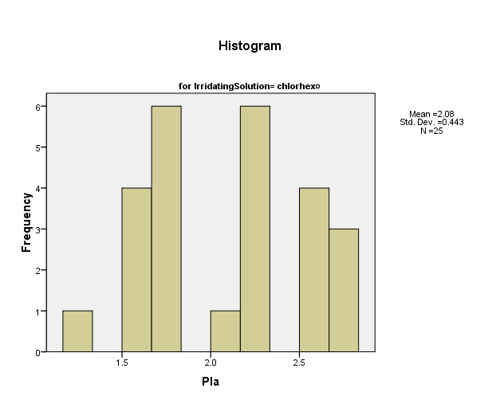

Normal Q-Q Plots
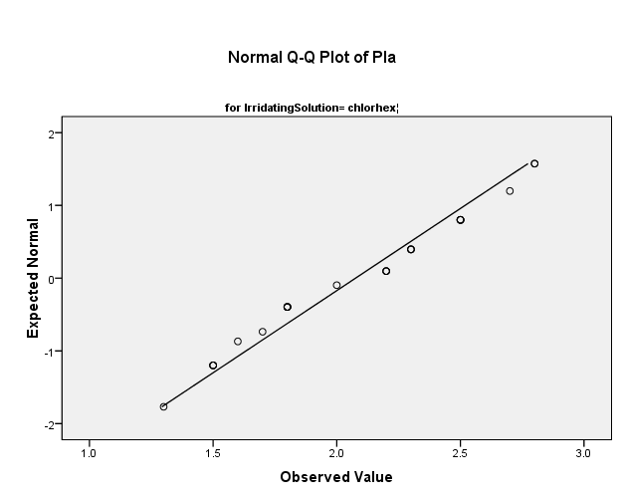

Detrended Normal Q-Q Plots
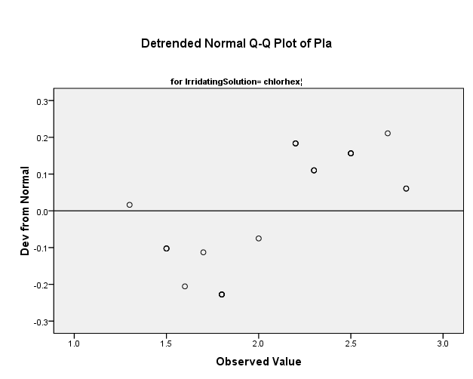

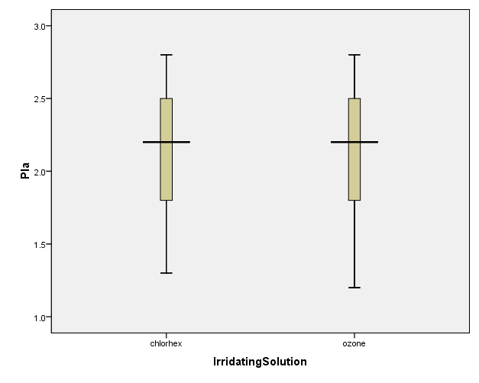

PIb

Histograms
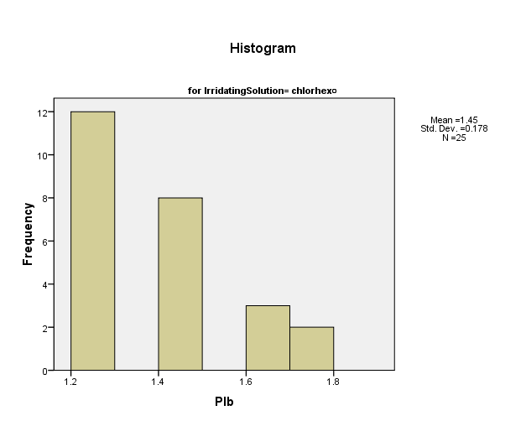

Normal Q-Q Plots
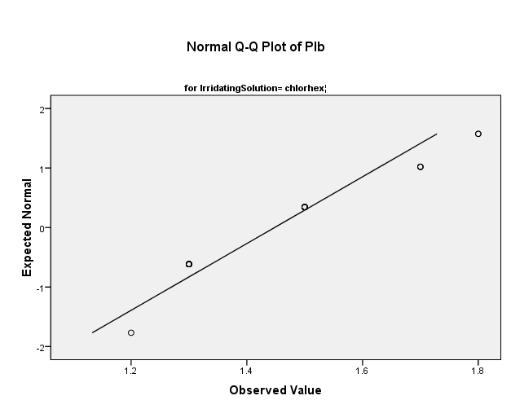

Detrended Normal Q-Q Plots
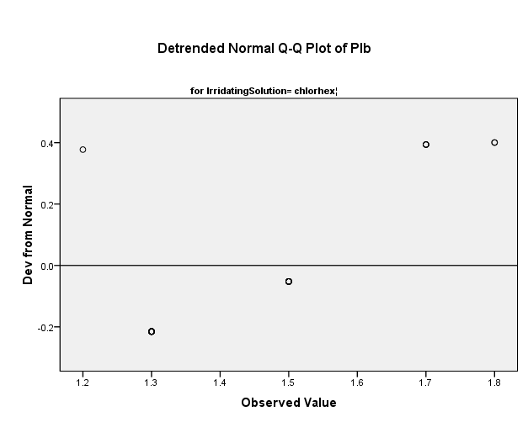

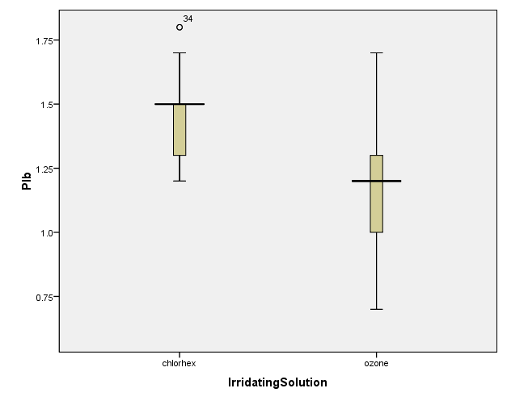

GIa

Histograms
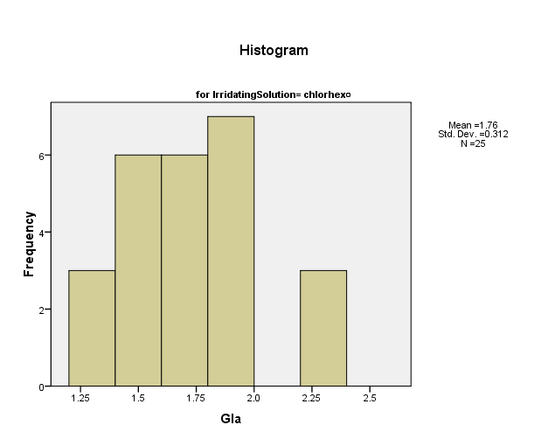

Normal Q-Q Plots
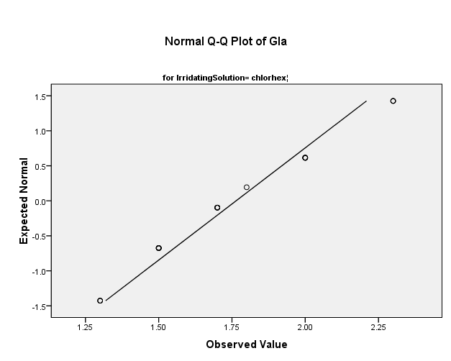

Detrended Normal Q-Q Plots
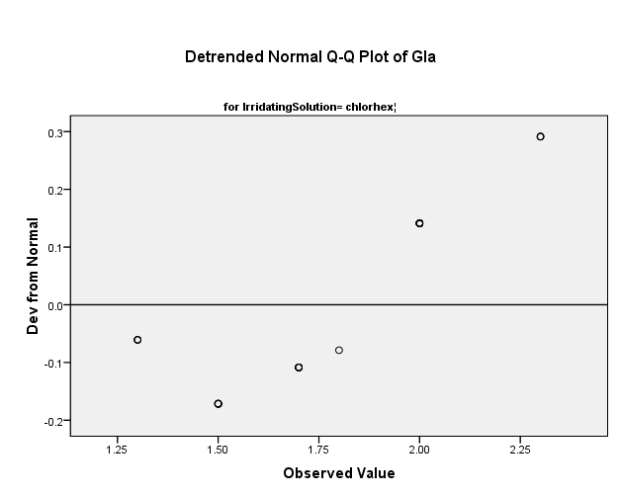

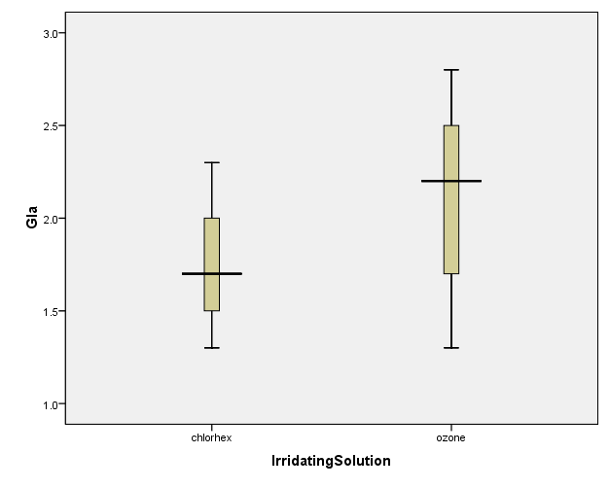

GIb

Histograms
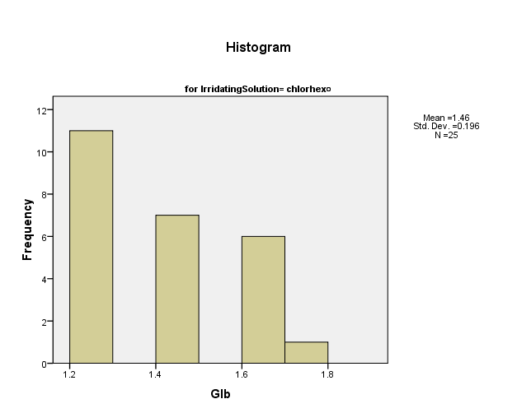

Normal Q-Q Plots
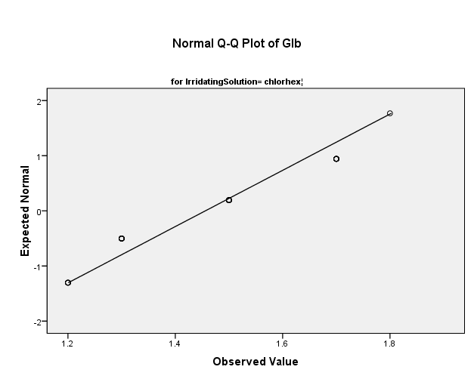

Detrended Normal Q-Q Plots
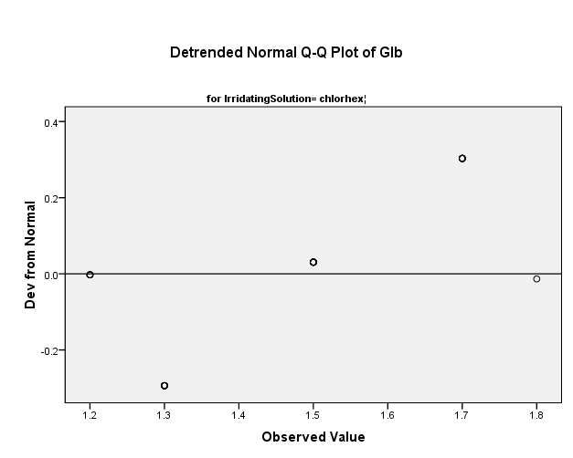

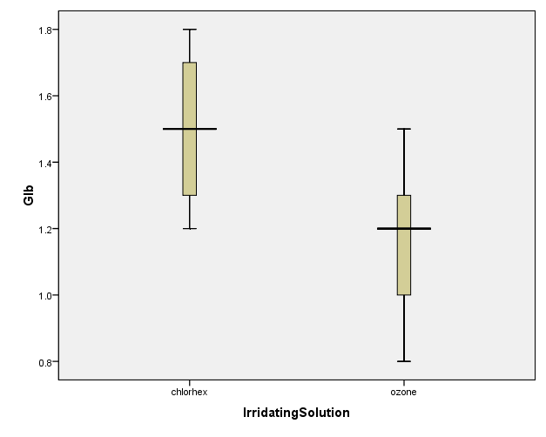

PPDa

Histograms
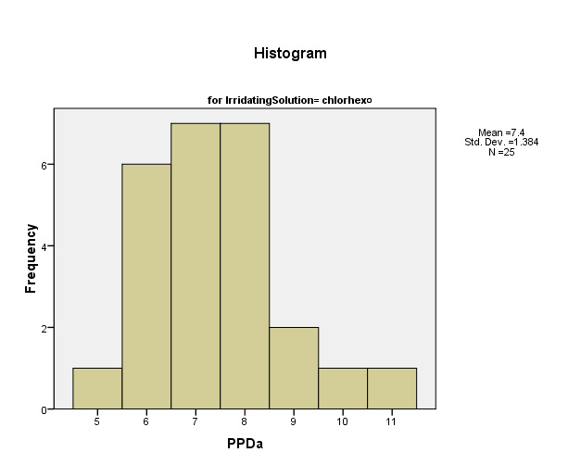

Normal Q-Q Plots
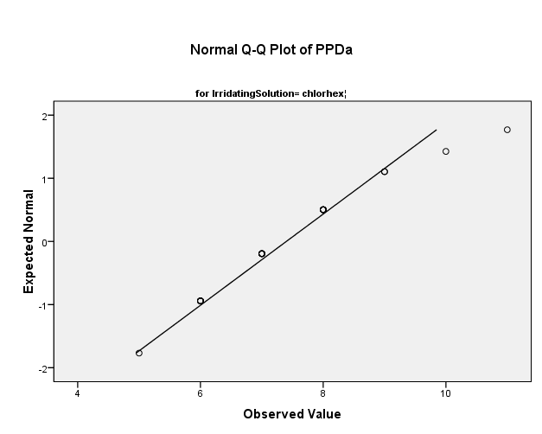

Detrended Normal Q-Q Plots
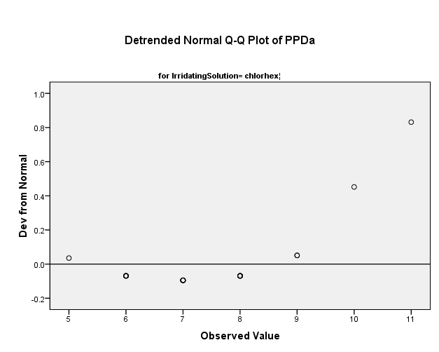

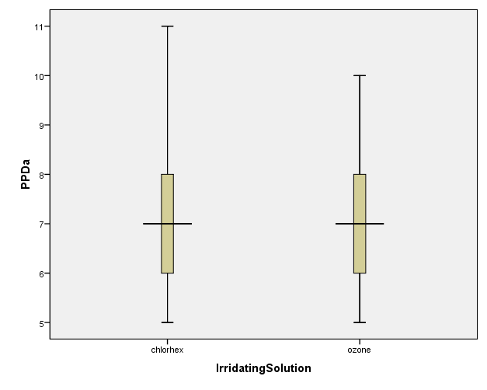

PPDb

Histograms
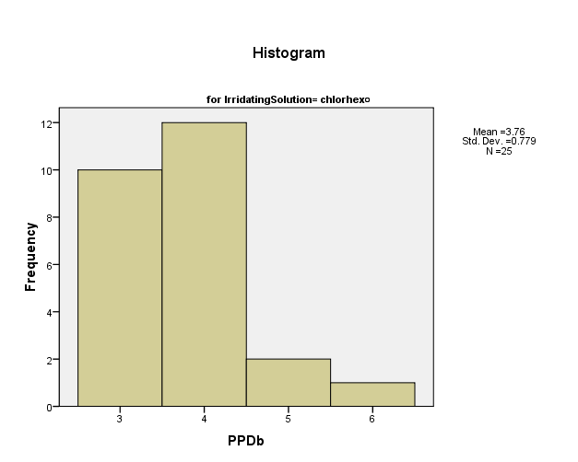

Normal Q-Q Plots
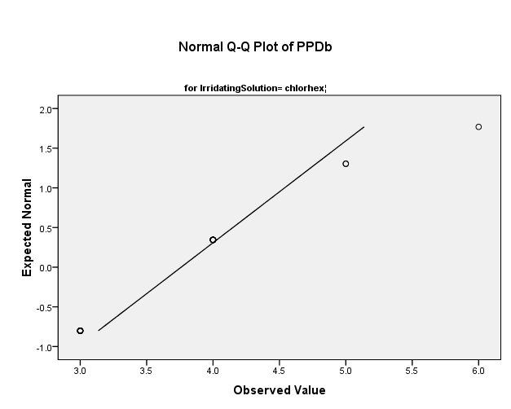

Detrended Normal Q-Q Plots
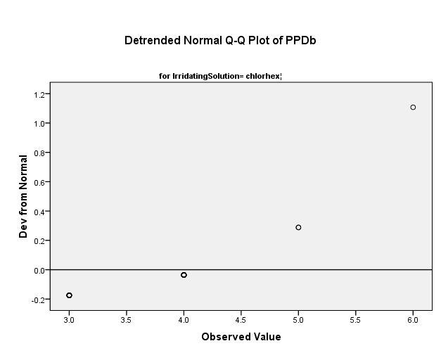

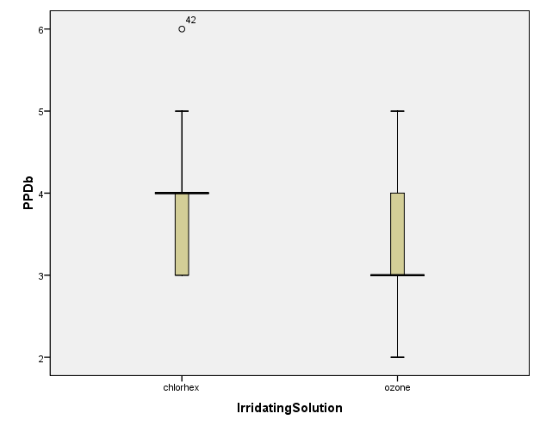

CALa

Histograms
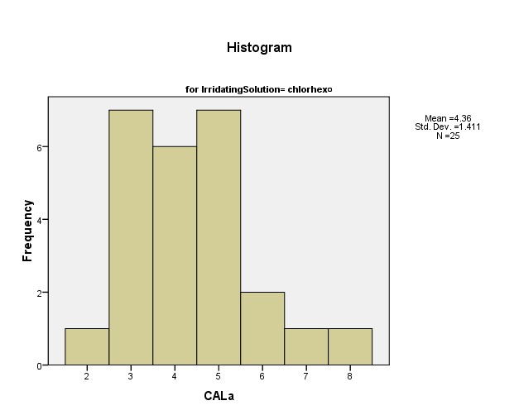

Normal Q-Q Plots
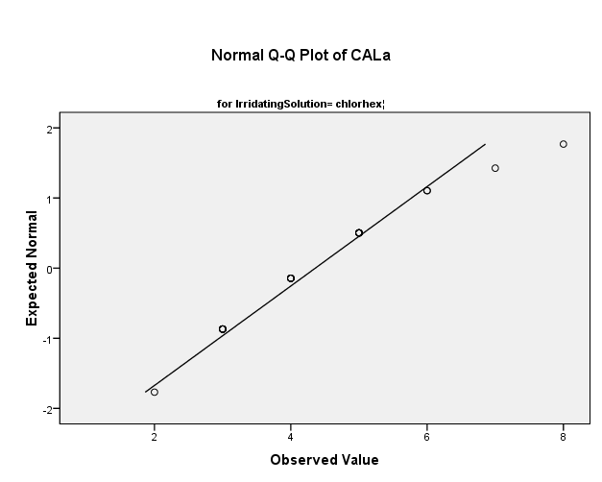

Detrended Normal Q-Q Plots
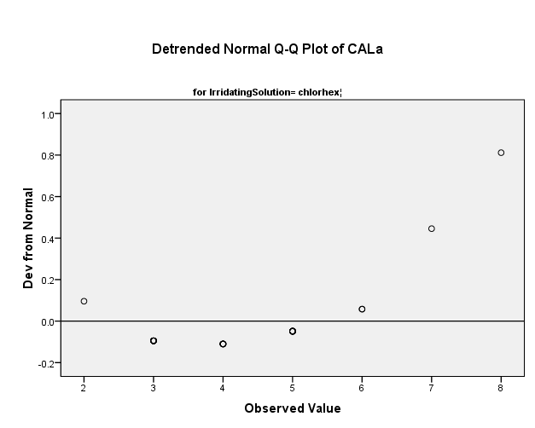

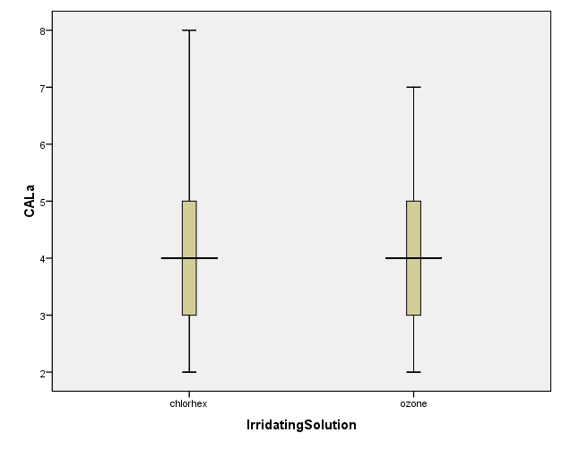

CALb

Histograms
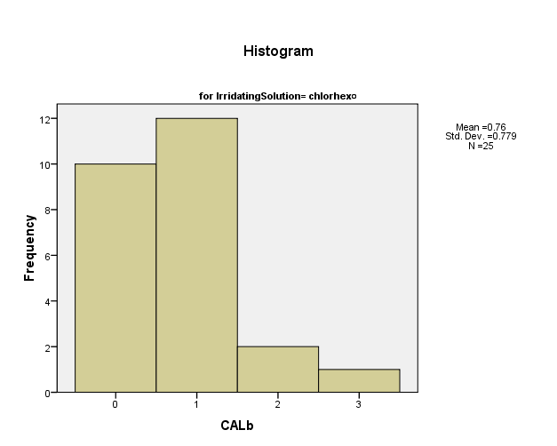

Normal Q-Q Plots
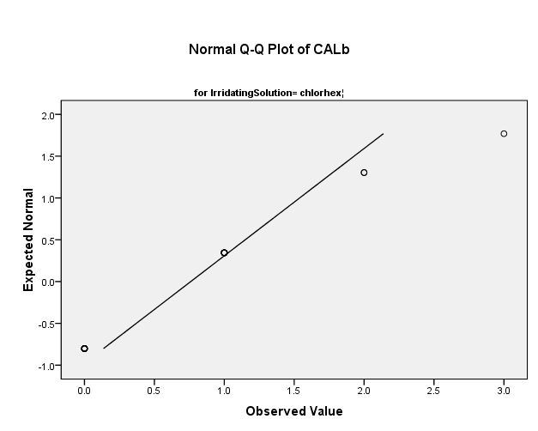

Detrended Normal Q-Q Plots
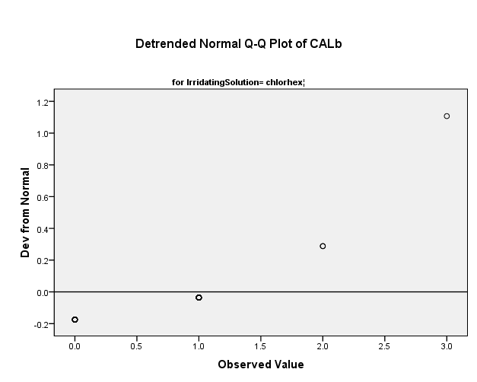

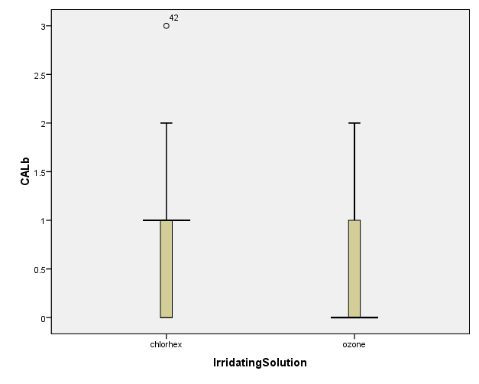

BOPa

Histograms
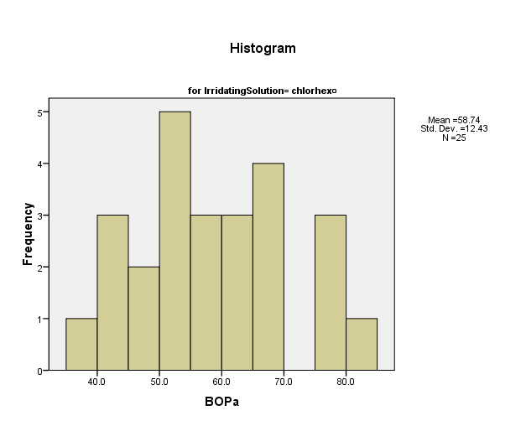

Normal Q-Q Plots
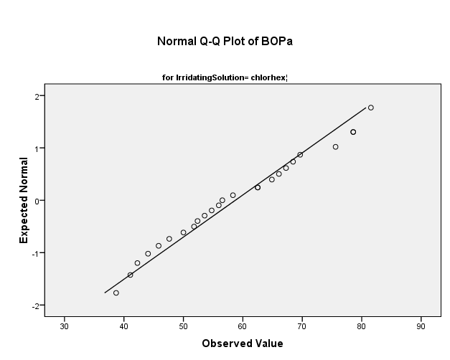

Detrended Normal Q-Q Plots
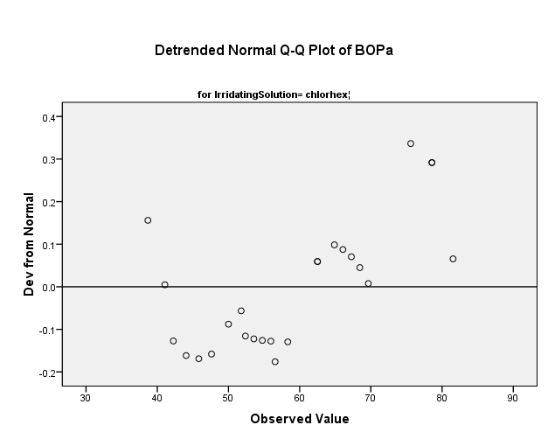

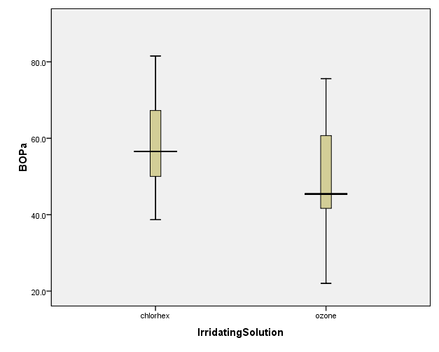

BOPb

Histograms
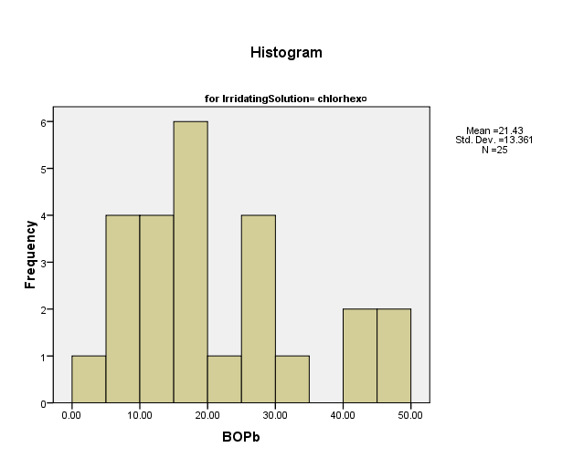

Normal Q-Q Plots
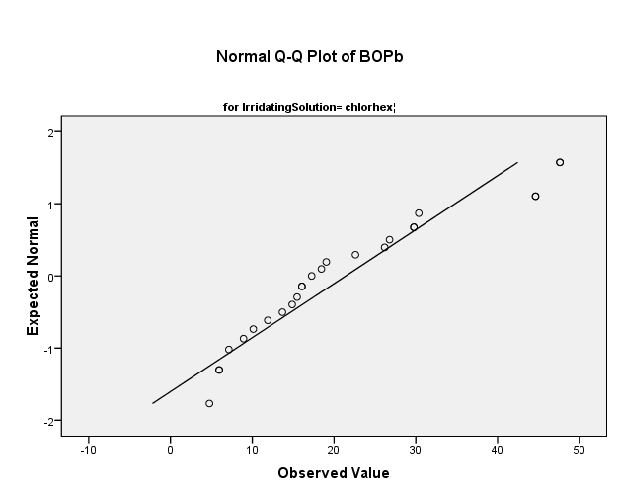

Detrended Normal Q-Q Plots
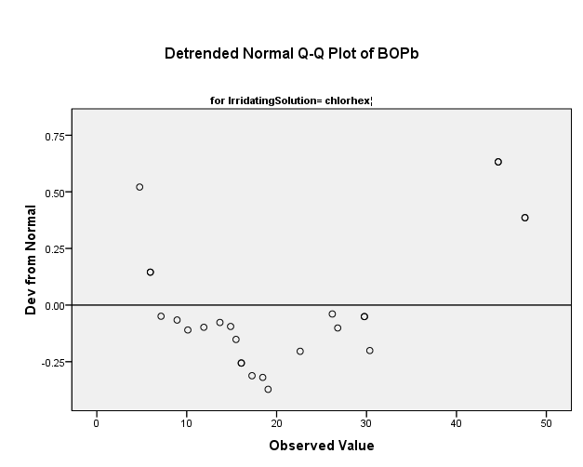

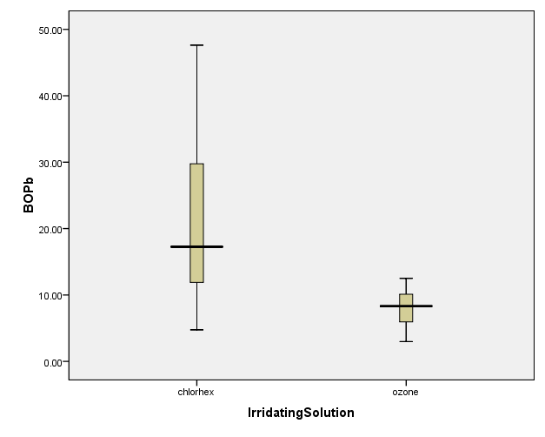

PISAa

Histograms
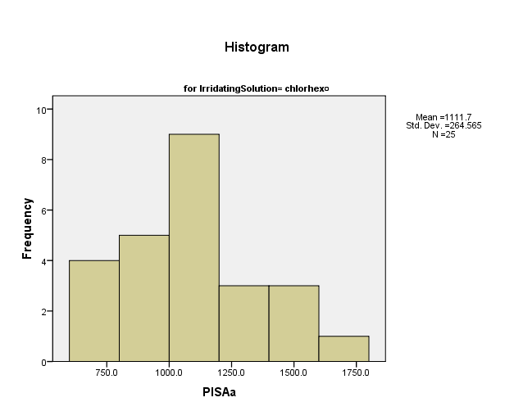

Normal Q-Q Plots
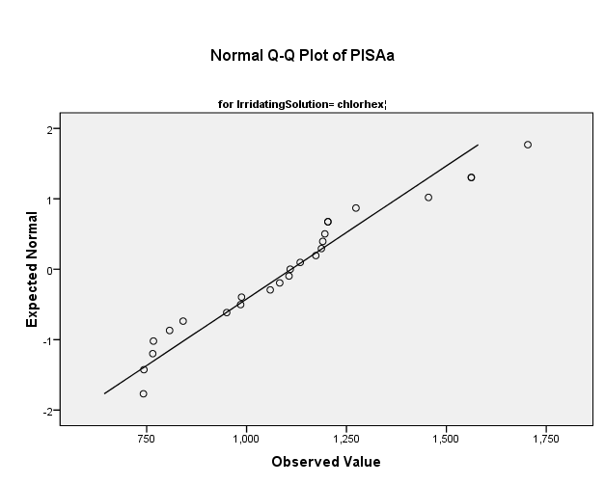

Detrended Normal Q-Q Plots
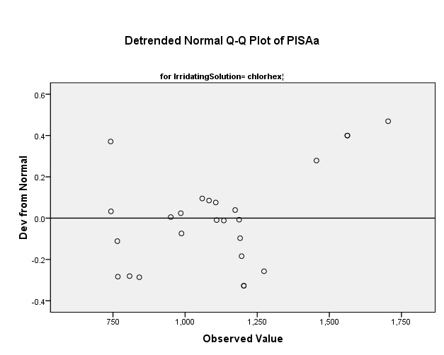

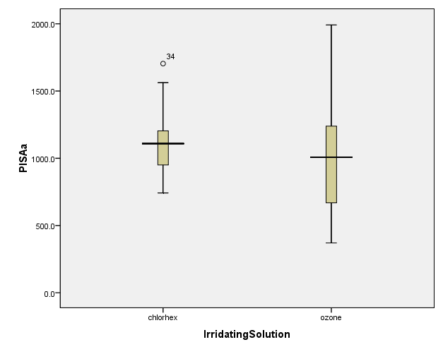

PISAb

Histograms
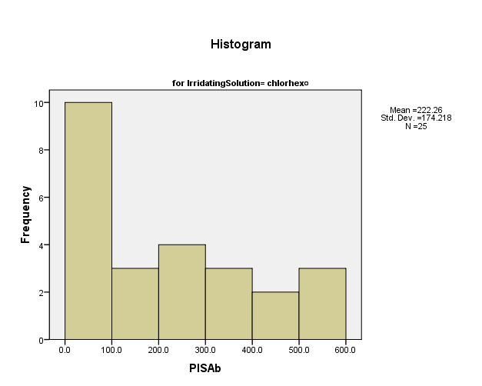

Normal Q-Q Plots
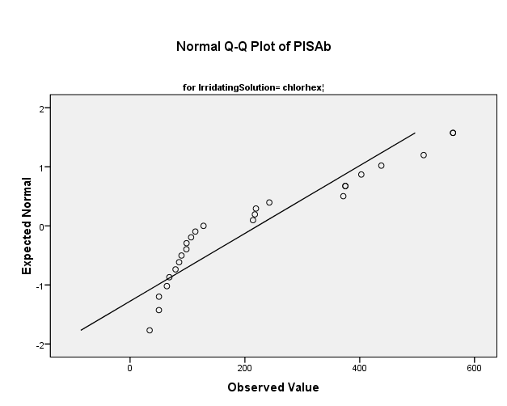

Detrended Normal Q-Q Plots
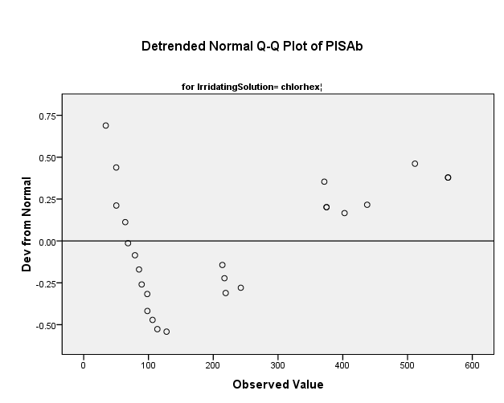

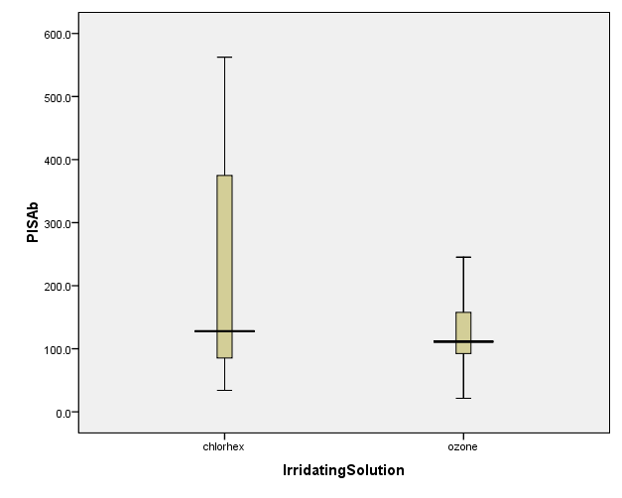

hsCRPa

Histograms
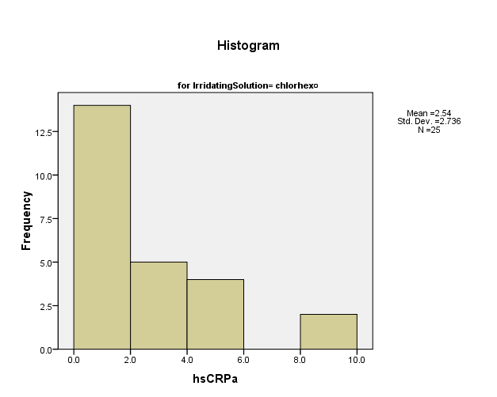

Normal Q-Q Plots
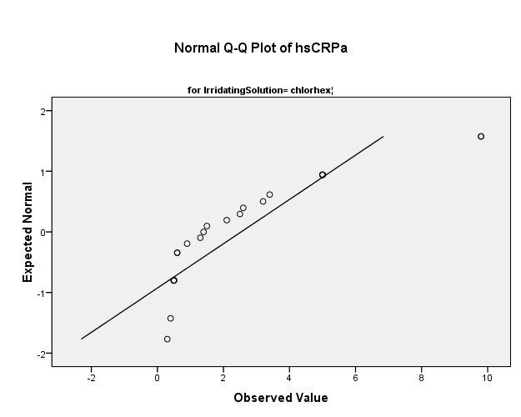

Detrended Normal Q-Q Plots
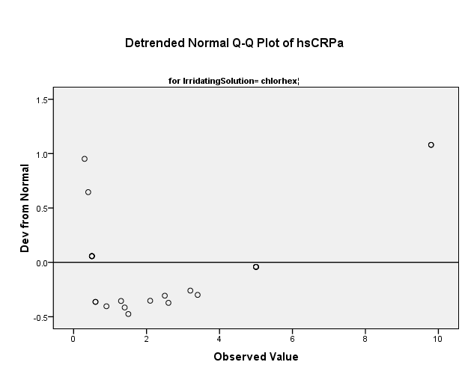

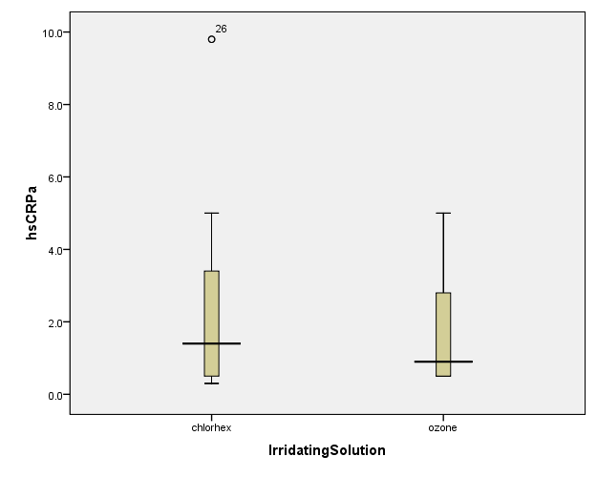

hsCRPb

Histograms
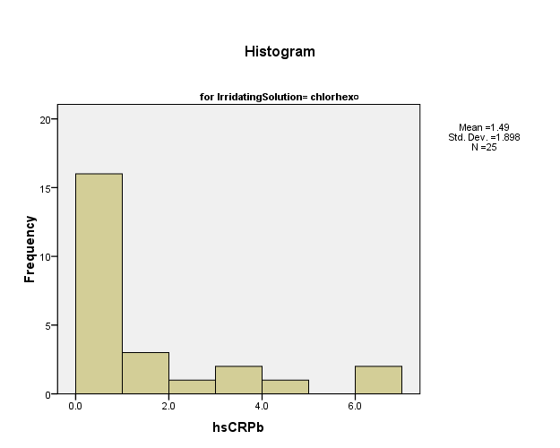

Normal Q-Q Plots
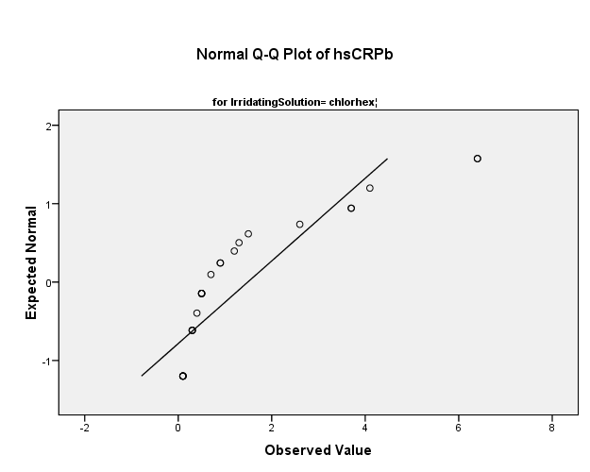

Detrended Normal Q-Q Plots
